|  |  |  |  |
| --- | --- | --- | --- |
| **Name** | Patil Kajal Bhagwan | | |
| **Class** | FYMCA (Sem-II) | | |
| **Roll No.** | 81 | **Date** |  |
| **Sub. Name & Code** | LAB on Digital Image Processing and Computer Vision ( CA LAB-VII(B) ) | | |

|  |  |  |  |
| --- | --- | --- | --- |
| **Practical No.** | 1(D) | **Title of the Practical** | Read an 8 bit image an then apply different image enhancement techniques: |

1. **Negative Of An Image**

I=imread('F:\kajal\MCA SEM 2\practical1.jpg');

imshow(I)

J=imcomplement(I);

figure, imshow(J)

* OUTPUT

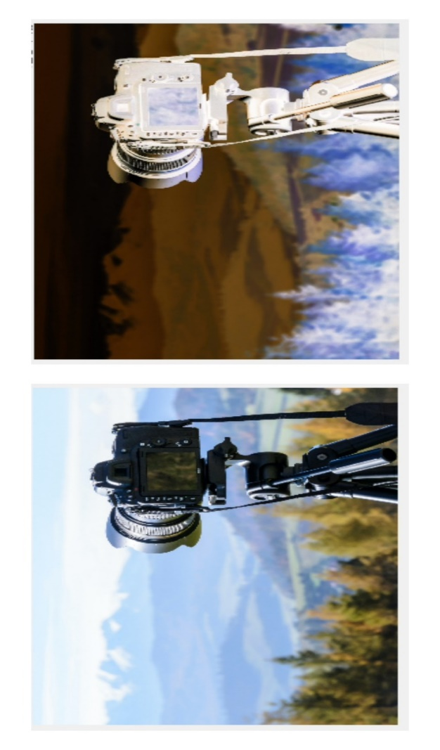

|  |  |  |  |
| --- | --- | --- | --- |
| **Name** | Patil Kajal Bhagwan | | |
| **Class** | FYMCA (Sem-II) | | |
| **Roll No.** | 81 | **Date** |  |
| **Sub. Name & Code** | LAB on Digital Image Processing and Computer Vision ( CA LAB-VII(B) ) | | |

|  |  |  |  |
| --- | --- | --- | --- |
| **Practical No.** | 2 | **Title of the Practical** | Read an image ,plot its histogram then do histogram equalization. Comment about the Results. |

clc

clear all

close all

a=imread('F:\kajal\MCA SEM 2\practical1.jpg');

b=rgb2gray(a);

subplot(2,2,1);

imshow(b);

title('Original Grayscale Image');

subplot(2,2,3);

imhist(b);

title('Histogram of Original Grayscale Image');

j=histeq(b);

subplot(2,2,2);

imshow(j);

title('Image After Histogram Equalization');

subplot(2,2,4);

imshow(j);

title('Histogram Of Image After Histogram Equalization');

* OUTPUT

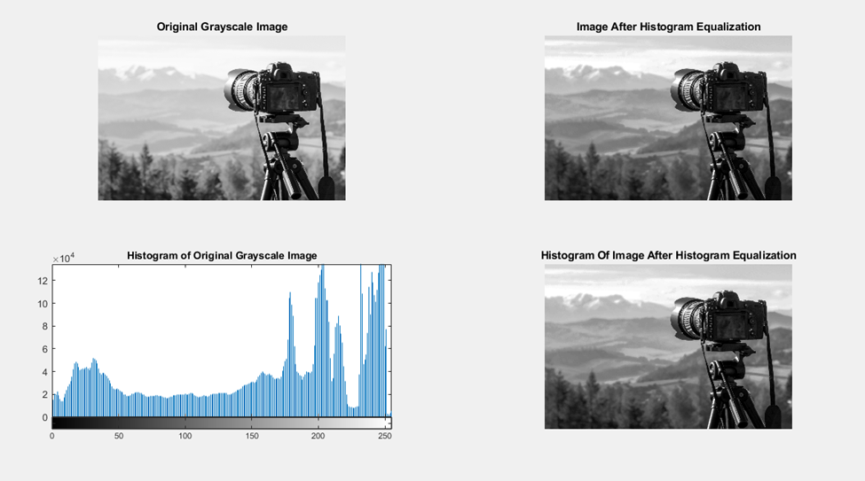

|  |  |  |  |
| --- | --- | --- | --- |
| **Name** | Patil Kajal Bhagwan | | |
| **Class** | FYMCA (Sem-II) | | |
| **Roll No.** | 81 | **Date** |  |
| **Sub. Name & Code** | LAB on Digital Image Processing and Computer Vision ( CA LAB-VII(B) ) | | |

|  |  |  |  |
| --- | --- | --- | --- |
| **Practical No.** | 3(c) | **Title of the Practical** | Read an image and to extract 8 different planes i.e. ‘bit plane slicing.” |

A=imread('F:\kajal\MCA SEM 2\hall.png');

B=zeros(size(A));

B=bitset(B,8,bitget(A,8));

B=bitset(B,7,bitget(A,7));

B=bitset(B,6,bitget(A,6));

B=bitset(B,5,bitget(A,5));

B=bitset(B,4,bitget(A,4));

B=bitset(B,3,bitget(A,3));

B=bitset(B,2,bitget(A,2));

B=uint8(B);

figure,imshow(B);

* OUTPUT

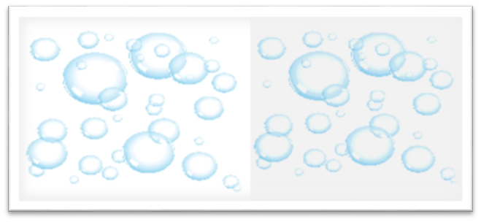

|  |  |  |  |
| --- | --- | --- | --- |
| **Name** | Patil Kajal Bhagwan | | |
| **Class** | FYMCA (Sem-II) | | |
| **Roll No.** | 81 | **Date** |  |
| **Sub. Name & Code** | LAB on Digital Image Processing and Computer Vision ( CA LAB-VII(B) ) | | |

|  |  |  |  |
| --- | --- | --- | --- |
| **Practical No.** |  | **Title of the Practical** | contrast-Stretching Transformations |

I=imread('tire.tif');

I2=im2double(I);

m=mean2(I2)

contrast1=1./(1+(m./(I2+eps)).^4);

contrast2=1./(1+(m./(I2+eps)).^5);

contrast3=1./(1+(m./(I2+eps)).^10);

imshow(I2)

figure,imshow(contrast1)

figure,imshow(contrast2)

figure,imshow(contrast3)

* OUTPUT

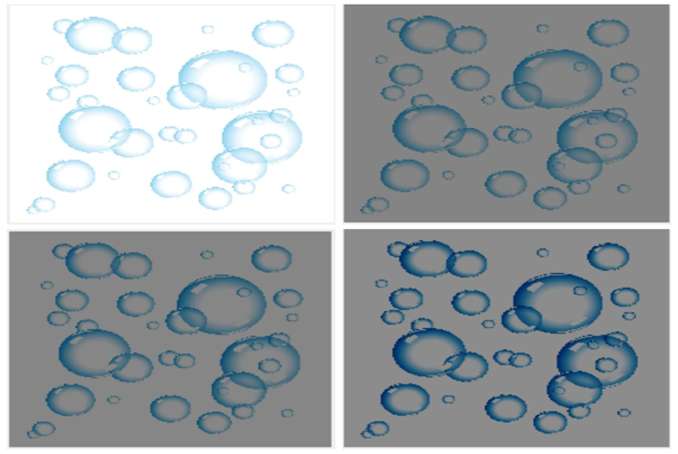

|  |  |  |  |
| --- | --- | --- | --- |
| **Name** | Patil Kajal Bhagwan | | |
| **Class** | FYMCA (Sem-II) | | |
| **Roll No.** | 81 | **Date** |  |
| **Sub. Name & Code** | LAB on Digital Image Processing and Computer Vision ( CA LAB-VII(B) ) | | |

|  |  |  |  |
| --- | --- | --- | --- |
| **Practical No.** | 7 | **Title of the Practical** | Implement and study the effect of Different Mask (Sobel, Prewitt and Roberts) [Sobel] |

clc;

close all;

clear all;

% Read Colour Image and convert it to a grey level Image

mycolourimage = imread('F:\kajal\MCA SEM 2\hall.jpg');

myimage = rgb2gray(mycolourimage);

subplot(3,3,1);

imshow(myimage); title('Original Image');

sobelhz = edge(myimage,'sobel','horizontal');

subplot(3,3,2);

imshow(sobelhz,[]); title('Sobel - Horizontal Edges');

sobelvrt = edge(myimage,'sobel','vertical');

subplot(3,3,3);

imshow(sobelhz,[]); title('Sobel - Vertical Edges');

sobelvrthz = edge(myimage,'sobel','both');

subplot(3,3,4);

imshow(sobelvrthz,[]); title('Sobel - All edges');

* OUTPUT

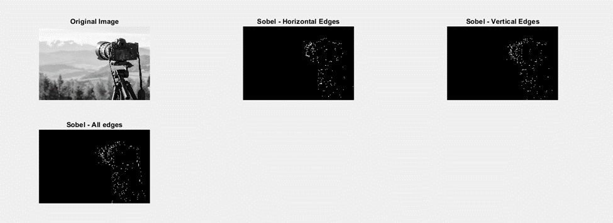

|  |  |  |  |
| --- | --- | --- | --- |
| **Name** | Patil Kajal Bhagwan | | |
| **Class** | FYMCA (Sem-II) | | |
| **Roll No.** | 81 | **Date** |  |
| **Sub. Name & Code** | LAB on Digital Image Processing and Computer Vision ( CA LAB-VII(B) ) | | |

|  |  |  |  |
| --- | --- | --- | --- |
| **Practical No.** | 7 | **Title of the Practical** | Implement and study the effect of Different Mask (Sobel, Prewitt and Roberts) [Prewitt] |

clc;

close all;

clear all;

% Read Colour Image and convert it to a grey level Image

% Display the original Image

mycolourimage = imread('F:\kajal\MCA SEM 2\practical1.jpg');

myimage = rgb2gray(mycolourimage);

subplot(3,3,1);

imshow(myimage); title('Original Image');

% Apply Prewitt Operator

% Display both horizontal and vertical Edges

Prewittsedg = edge(myimage,'prewitt');

subplot(3,3,6);

imshow(Prewittsedg,[]); title('Prewitt - Edges');

* OUTPUT

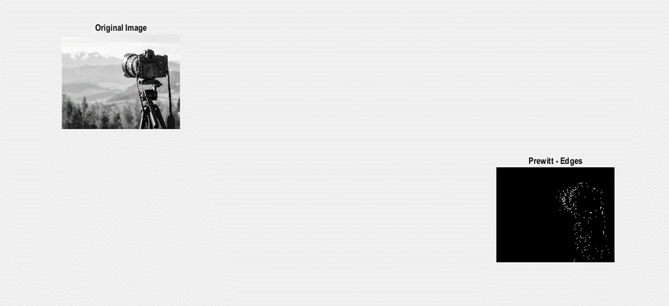

|  |  |  |  |
| --- | --- | --- | --- |
| **Name** | Patil Kajal Bhagwan | | |
| **Class** | FYMCA (Sem-II) | | |
| **Roll No.** | 81 | **Date** |  |
| **Sub. Name & Code** | LAB on Digital Image Processing and Computer Vision ( CA LAB-VII(B) ) | | |

|  |  |  |  |
| --- | --- | --- | --- |
| **Practical No.** | 7 | **Title of the Practical** | Implement and study the effect of Different Mask (Sobel, Prewitt and Roberts) [Roberts] |

clc;

close all;

clear all;

% Read Colour Image and convert it to a grey level Image

% Display the original Image

mycolourimage = imread('F:\kajal\MCA SEM 2\practical1.jpg');

myimage = rgb2gray(mycolourimage);

subplot(3,3,1);

imshow(myimage); title('Original Image');

% Apply Roberts Operator

% Display both horizontal and vertical Edges

robertsedg = edge(myimage,'roberts');

subplot(3,3,5);

imshow(robertsedg,[]); title('Roberts - Edges')

* OUTPUT

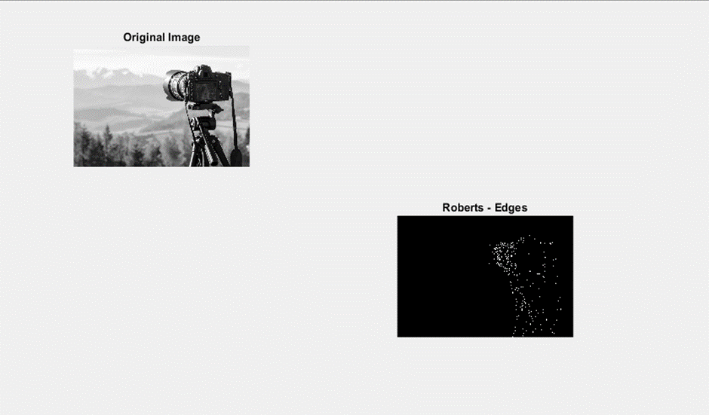

|  |  |  |  |
| --- | --- | --- | --- |
| **Name** | Patil Kajal Bhagwan | | |
| **Class** | FYMCA (Sem-II) | | |
| **Roll No.** | 81 | **Date** |  |
| **Sub. Name & Code** | LAB on Digital Image Processing and Computer Vision ( CA LAB-VII(B) ) | | |

|  |  |  |  |
| --- | --- | --- | --- |
| **Practical No.** |  | **Title of the Practical** |  |